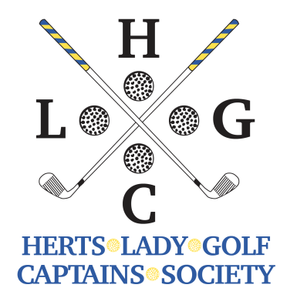
AUTUMN MEETING
Monday 12th August 2022 at Bedford and County Golf Club
Green lane, Clapham, Bedford, MK41 6ET, Telephone 01234 352617

- Coffee/tea will be provided before play (the kitchen will be open for you to buy food)
- One course meal and changing is optional
- Food will be provided on a rolling basis as you come in. Prizes will be forwarded on after the event.
- Buggies, if required, should be arranged directly with the club.
- It would be appreciated if you could wear Society colours (yellow and blue) at the meeting.
- Entries will be taken on a first come, first served basis BUT we would appreciate application forms as early as possible please to allow enough tee times to be booked to avoid disappointment.
- The start sheet will be sent to all email addresses
- Pay by bank transfer to HLGCS by the closing date Sort code: 30-99-31 Account Number: 00170701 Or send a cheque (post-dated to the closing date) made payable to HLGCS:
Sue Roberts, 4 Wellingham Avenue, Hitchin, Herts., SG5 2UJ
Email: sueroberts147@hotmail.co.uk

Format is better ball pairs. 85% of course handicap. Entries accepted to closing date of 22nd August 2022.
Enter in pairs and if you wish to play with another pair, please enter all 4 names on the form.
£46 per player. Tee times from 12 noon.
Player 1 & H’cap Index |  | Player 3 & H’cap Index
Current club |  | Current club
Email |  | Email
Player 2 & H’cap Index |  | Player 4 & H’cap Index
Current club |  | Current club
Email |  | Email
If paying by bank transfer, please state date of payment and name of payee:

Please state any dietary requirements:

PLEASE NOTE – no refund will be given after the closing date and entries will not be accepted unless the membership subscription for 2022 has been paid

